Daniel Schween

10/16/2024

CS 255 SNHU

# CS 255 System Design Document

***DriverPass***

## UML Diagrams

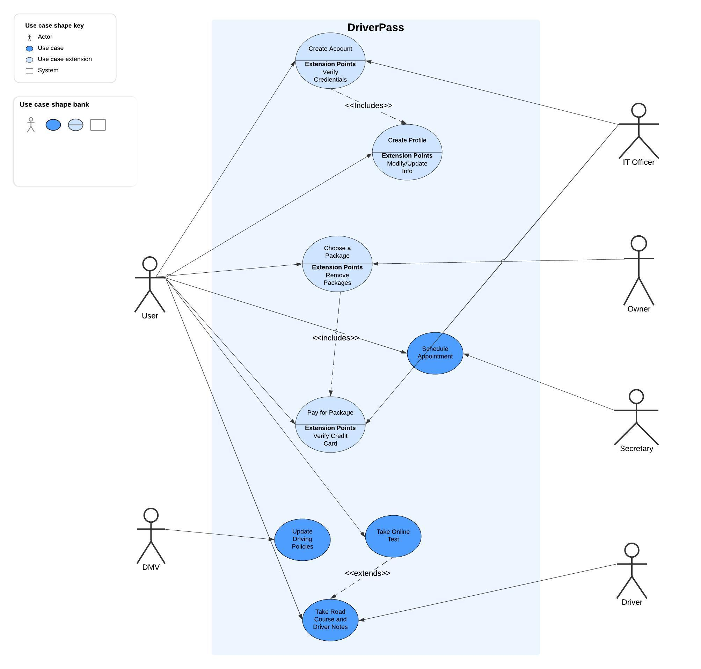**UML Use Case Diagram**

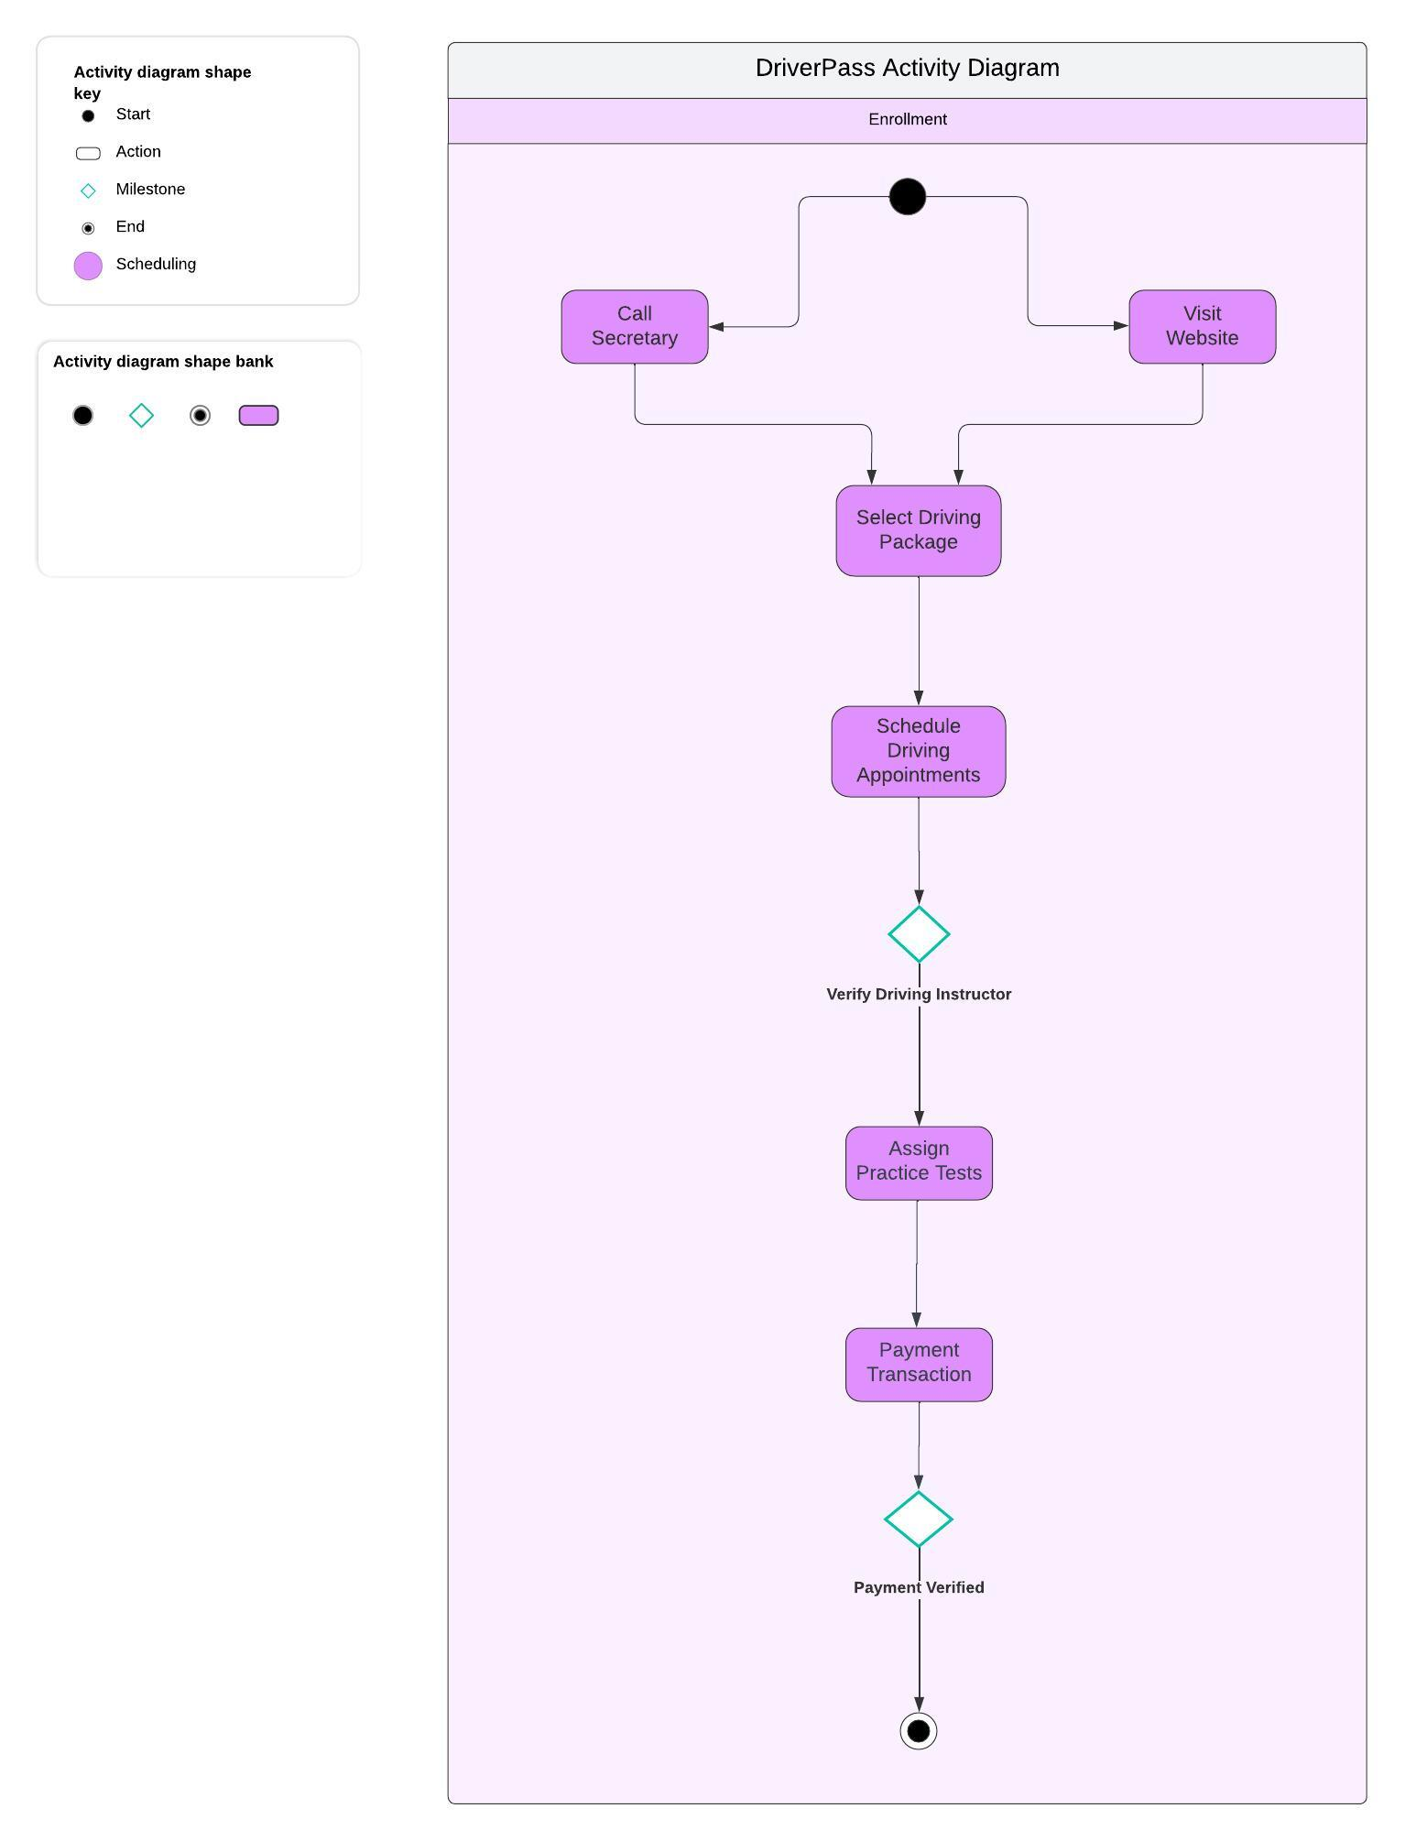**UML Activity Diagrams**

### UML Sequence Diagram

***Enrollment***

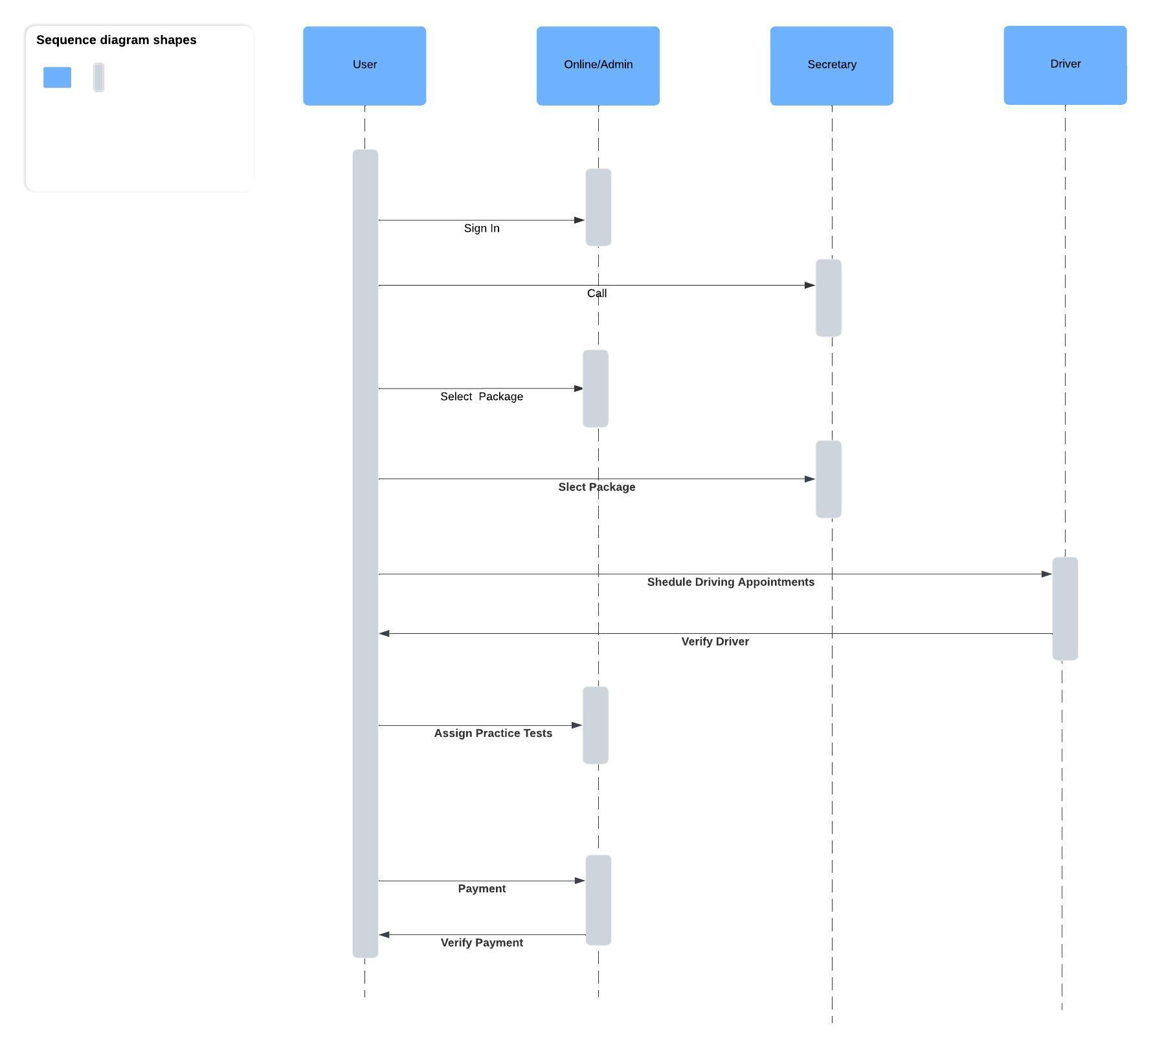

### UML Class Diagram

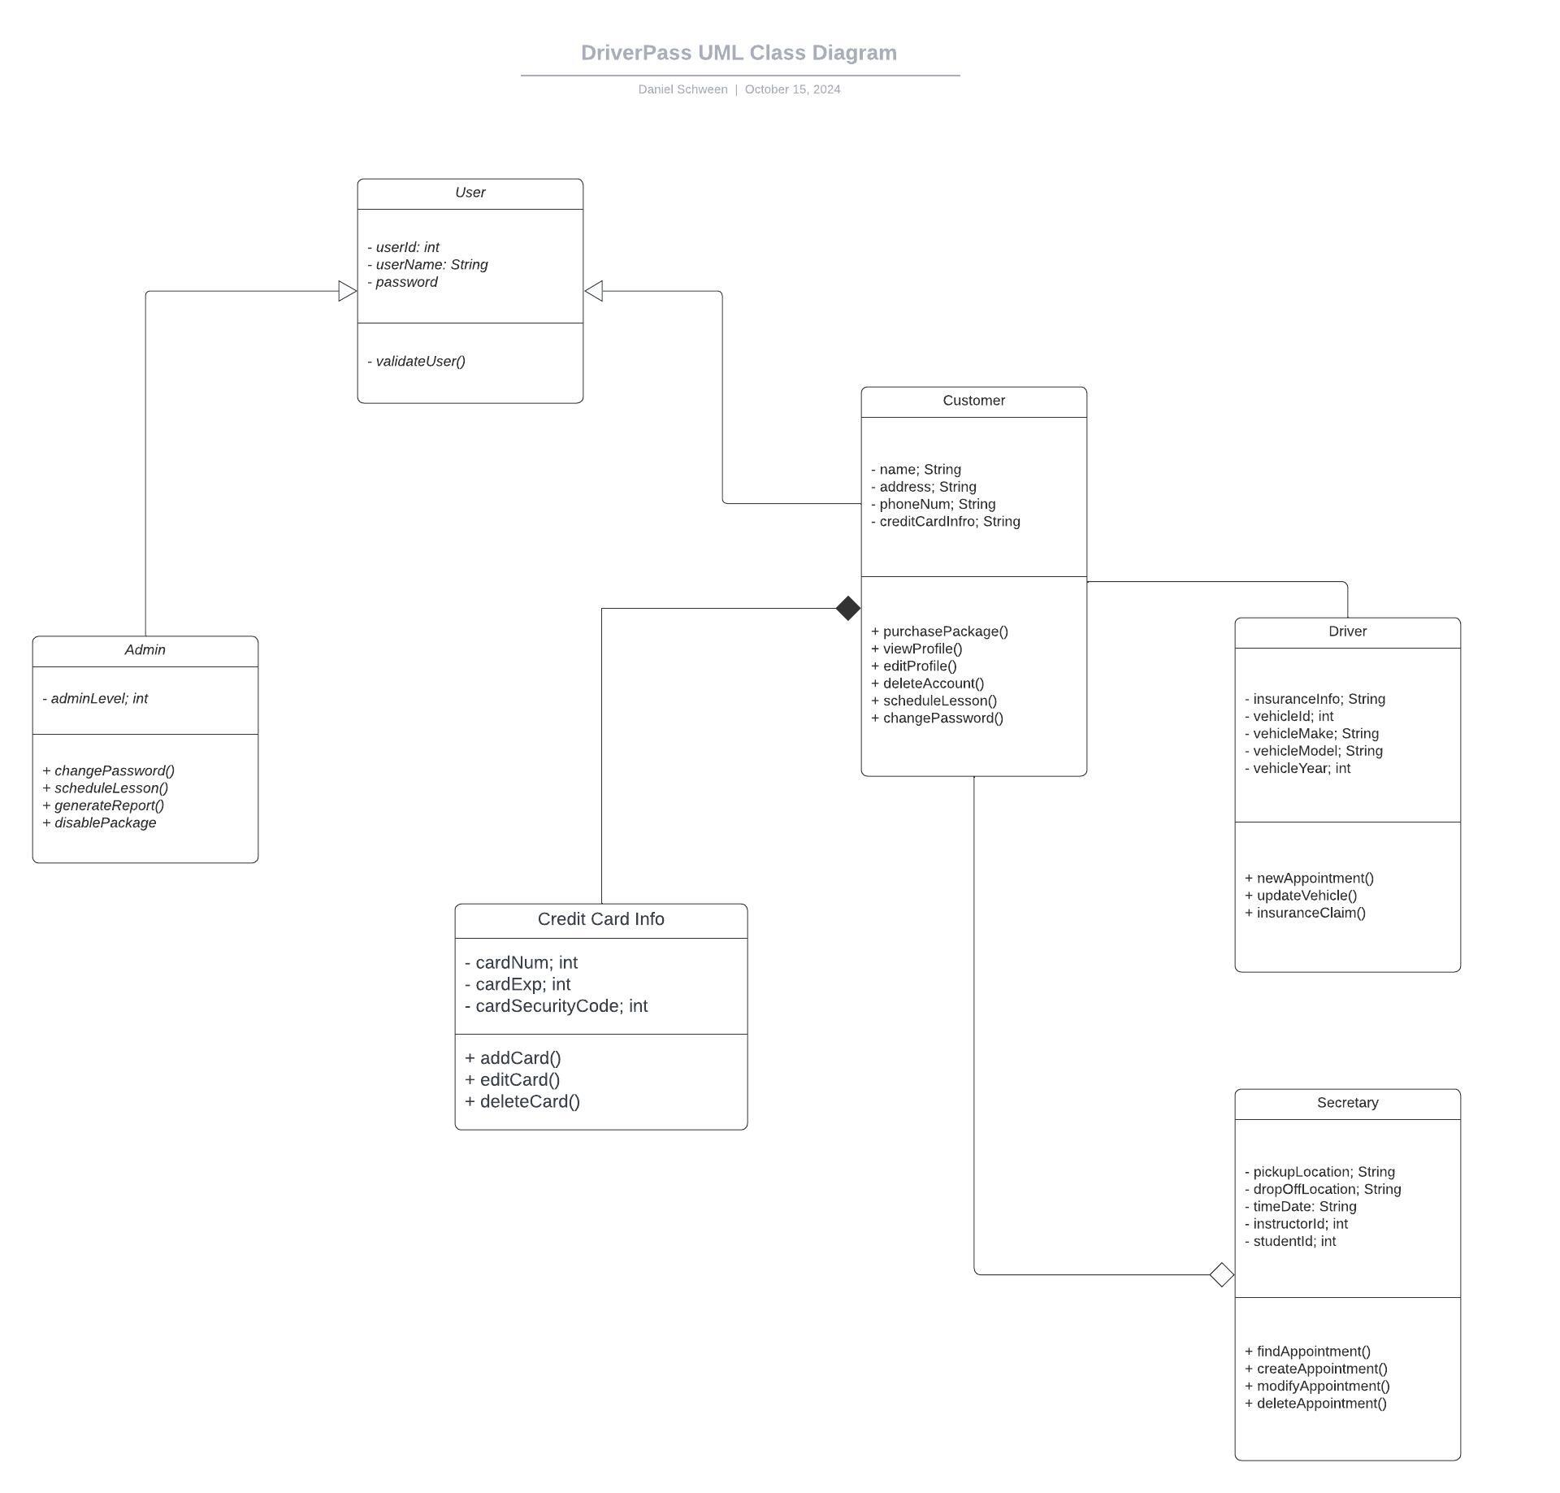

## Technical Requirements

The hardware of the user’s computer should be able to support a basic web interface. It is not an advanced application, but the hardware should be modern. Since we are developing an application in 2024, the user should have a minimum of Windows 10 or a later version of iOS to support the newer interface features.

Regardless of hardware and software requirements, a huge technical requirement is security. Since DriverPass will have access to customers’ information and credit card information, they are obligated to protect their sensitive data. Two-step authorization and a complex, unique password are essential to protect our user’s information. We must also back up data on the cloud to protect the client from a cyber attack or system failure. Another key requirement would be the back end. DriverPass must have a full-time developer to aid in customer support and update the user interface. Interface updates will be a key feature for DriverPass so the user has an optimal experience when using the system.

These technical requirements weren’t highlighted in the diagrams because the diagrams focused more on functional requirements. In fact, the technical requirements can have a diagram for itsself. The IT department and administration will support these technical requirements to help the business grow and attract more users.